Appendix J:
Interim Communications Plan

1. Background
A significant amount of research into NHWN’s communications requirements has taken place during 2009/10. Included within that work has been the development of plans and products to address certain needs. Much of this work concluded at the end of March 2010 and is also appended to the Business Plan, notably:
- The case studies of NHW good practice (Appendix H), conducted by ERS. As well as case studies this includes profiling research about current NHW grassroots members.
- Branding and asset building (Appendix I), conducted by the Design Council and Live-Work. This includes research into how NHW can connect with potential new audiences as well as the existing grassroots, and initial design work for the new NHWN website which is likely to be the primary communications tool.
- The feasibility study for a single communications system (Appendix L), conducted by Tribal. This explores options for enabling independent, two-way communication between NHWN and its grassroots members – something that is not currently possible and that is critical to achieving internal communication.

Two further areas of communications development are scheduled to take place during the first quarter of 2010/11:
- Further research by ERS, exploring how NHW might engage with Black and Minority Ethnic groups in particular.
- Development of the new NHWN website by the Spencer du Bois agency, for launch in June 2010. This work also ties in with: the development of a cohesive NHWN brand and visual identity, the means for NHWN to reach out to and engage new audiences, and the ability of NHWN to communicate with its grassroots members (at least until there is a single communications system).

2. Key Communications Goals
The Communications Strategy should be developed directly from the Aims and Objectives of the 2010-15 Business Plan. There are likely to be two core strands, focusing on external and internal communications, and the principal strategic drivers are as follows:

Aim A: Support and develop the network’s grassroots in keeping with their needs
- Improve information flows within the network so that there is effective and accessible two-way communication between the grassroots and national levels. In this way Scheme members will be well informed about issues that are relevant to their work, and at national level the network will be informed about the common views and needs of Scheme members.
- Trial and launch a single communication system that enables independent communication between the network nationally and all Scheme members by April 2013 (see Appendix L).

Aim B: Expand the inclusivity of Neighbourhood and Home Watch
i Promote inclusivity via the website to inspire new Schemes to register. This includes (but is not limited to): resonant messaging, relevant opportunities to become involved and easy actions that people can take.

Aim C: Build the profile and influence of Neighbourhood and Home Watch
- Build and consistently promote the NHWN brand so that public perception of NHW increasingly reflects the network’s 5-year mission statement. This includes (but is not limited to): the NHWN website, media coverage and key events.

As communications is fundamental to effective delivery of much of the Business Plan, the Communications Strategy needs to be grounded in an understanding of what NHWN is seeking to achieve overall.

The 2010/11 Action Plan includes a number of communications deliverables, most notably:
- Launch of the new NHWN website (in Quarter 1)
- Completion of the NHWN Communications Strategy (in Quarter 2) and
- Agreeing a strategy for implementing the single communications system (in Quarter 3)

3. Developing the Communications Strategy
This interim communications plan is intended as a context document, containing background and pointers; it is not intended to be a first draft of the actual Communications Strategy, and it is assumed that the final Strategy will differ. Key steps in developing the Communications Strategy itself could be as follows:
- Consider the 2010-15 NHWN Business Plan and draw out the key communications requirements that it contains.
- Consider the full body of evidence within the communications research and development work carried out for NHWN (as in 1 above), and draw out the key themes that could frame effective implementation.
- Engage with the Spencer du Bois consultancy to: draw upon their communications expertise; seek their input to the Strategy development, and; as far as is possible ensure that the website, branding and asset building carried out by Spencer du Bois optimises delivery of both external and internal communications goals.
- Develop the Communications Strategy in the light of the above.

4. Communications Issues to Consider
In developing the Communications Strategy it is worth considering the following issues. These are not intended to be comprehensive or accurate sets of issues, and in any case may need prioritising to develop a focused Communications Strategy.

a) What audiences does NHWN wish to communicate with?
Externally:
- The public, media, key partners and decision-makers: to counter inaccurate perceptions of what NHW is and build its profile based upon what it actually is
- The public, to encourage new schemes to launch
- Groups that are harder to reach and whose engagement would contribute to the inclusivity Aim (for example BME groups, under-30s and people in high crime areas)
Internally:
- Existing scheme members
- Existing scheme co-ordinators
- Regional Representatives and/or people interested in regional activity

b) What are the key messages for these audiences?
Externally and internally: NHWN’s vision, mission and values.
Externally:
- NHW has changed, it may not be what you expect
- NHW is dedicated to improving life at the community level
- NHW is a powerful force for change, with X million members and influential connections
- If you want to help your community, NHW can really help you
Internally:
- We are here for you, the grassroots members
- We provide information, resources and help in response to your needs
- We represent your views to bring about positive change
- By working together towards common goals we are building a better society

c) With what methods can NHWN communicate?
- The NHWN website
- Broadcast and printed media
- Social media
- Direct e-mail and bulletins to schemes and grassroots members
- Training toolkits and other NHW materials
- With a cohesive and resonant branding and visual identity
- Via partner organisations in the statutory and voluntary sectors
- Via key forums such as the NSGWI
- Via potential commercial sponsors

d) What structure could the Communications Strategy follow?
This depends on how the Strategy will be used: who exactly it is written for, who will use it, who will see it, etc. Some factors to consider include:
- Clearly linking the Communications Strategy with delivery of the NHWN Business Plan
- Setting clear longer-term objectives in keeping with the Business Plan, up to 2015
- Including a more detailed Action Plan for shorter-term deliverables, probably on an annual basis

e) Reviewing the Communications Strategy
Like any plan or strategy it is prudent to include a mechanism for evaluation. Whilst this should not be onerous, it should be robust enough to both review performance against planned activity and check that delivery remains grounded in external reality. A simple ‘plan-do-review’ approach is advisable, and that could be synchronised with the annual review of the Business Plan from 2011/12 onwards.

Appendix K:
A VRQ for Neighbourhood Watch (Tribal report)

Feasibility Study into the development of a training programme/qualification for the NHW

Background
NHW is organised as a grass roots organisation, with almost all, organised at Police Force level – i.e. times 43 in England and Wales.

Some police forces and indeed some NHW schemes sort out and organise their own NHW training needs, but very few do this. We do not have a breakdown of who does what.

Two years ago an arrangement was put in place for existing Training Toolkits to be reviewed, updated and new modules to be written in an interactive style. These have always been available on the Home Office NHW mini-site but recently have been added to the www.mynhw.co.uk website. This is where NHW members can go to receive generic training across a range of subjects.

The training toolkit is about to be reviewed again and additional chapters written by 31/3/2010. The style of the existing toolkit will be reviewed by the Design Council and they will employ consultants to put top quality design around this around April 2010.

Aim of the Feasibility Study
This feasibility study has been commissioned to explore and recognise:
- Where we are now;
- Identify whether having a VRQ/NVQ capability might be a useful/essential position for NHW (i.e. is this where we want to be?, we don't know until someone explores the opportunities!);
- Provide a range of options covering the development of accredited or non-accredited training;
- Feed into the new sustainability plan being developed for NHWN; and
- Explores exactly how the options might be delivered.

The feasibility study will also endeavour to set out the costs that NHW would incur in setting up a scheme and on-going running costs, exploring the potential or likelihood of funding which might be available to cover these costs from various grants.

What is an Accredited Training Programme/Qualification?
Prior to getting into the depths of this feasibility study it is important to distinguish between the different types of qualifications (accredited training) that are on offer. They generally fall into either one of the following two categories:
- Vocationally Related Qualification (VRQ); and
- National Vocational Qualification (NVQ)

The difference between the two types of qualifications can be defined as:

NVQs (National Vocational Qualifications) recognise your competence in your specific area of expertise - that is your ability and skills in carrying out your job effectively. This is demonstrated through evidence you provide and supported by witness statements from colleagues and observations by a qualified assessor appointed to you. The evidence you produce must also show that you understand what you do and why - known as underpinning knowledge - that meets the requirements of the National Standards being assessed and supports you in your business activity.

VRQs (Vocationally Related Qualifications) are more focused on developing and assessing your knowledge and understanding. They are delivered through a taught programme and may have a work placement running alongside - this provides an opportunity to utilise what you are learning and develop your skills as you work through the programme. To achieve the VRQ you will work through a series of set tasks that will help demonstrate your knowledge and understanding. To achieve the certificate there will be an end of programme multiple choice exam where you will demonstrate what you have learnt in response to set questions for different scenarios.

VRQs are typically undertaken by candidates wishing to progress their career, either in preparation to taking an NVQ at the same level or whilst developing their knowledge and expertise to achieve the next level in the same suite of qualifications; they may also be used in helping a candidate step-up into a team leader or management role. Candidates who wish to undertake an NVQ without the VRQ support must demonstrate that they have the relevant skills and knowledge beforehand.

What is a non-accredited training programme?
The term ‘non-accredited learning’ is used to describe formal and non-formal provision which does not lead directly to any form of external accreditation, award or qualification. Non-accredited training will cover the same topics as accredited training, but does not allow the individual to gain a qualification.

Currently, through the Neighbourhood Watch Toolkit, individuals can engage in non-accredited training:

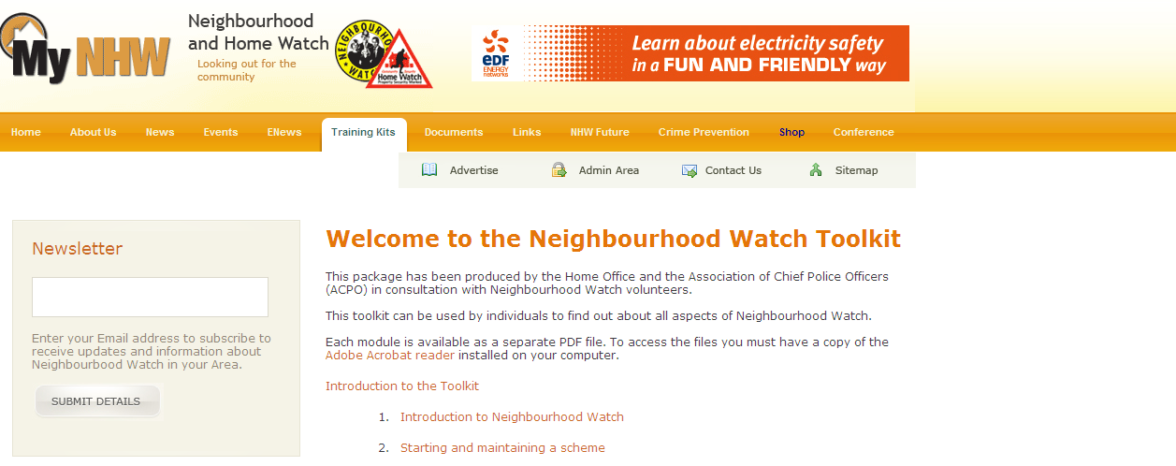
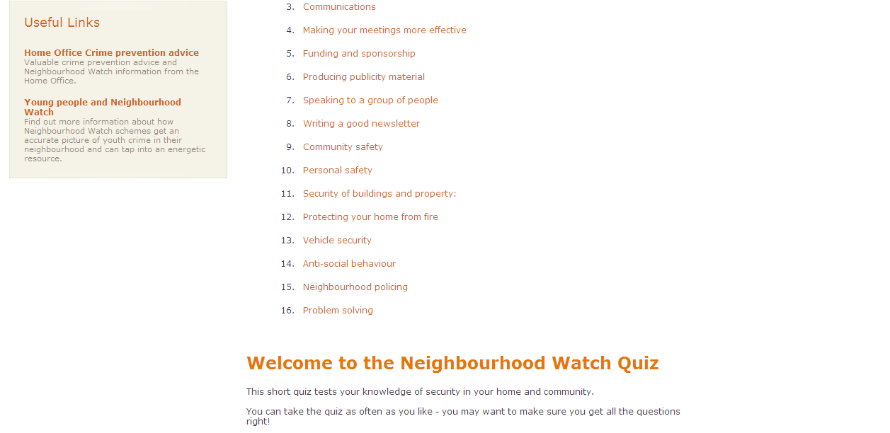

Where are we now?
Two years ago the existing Training Toolkits were reviewed, updated and new modules written in an interactive style. These have always been available on the Home Office NHW mini-site but recently have been added to the www.mynhw.co.uk website. This is where NHW members can go to receive generic training across a range of subjects.

The training toolkit is about to be reviewed again and additional chapters written by 31/3/2010. The style of the existing toolkit will be reviewed by the Design Council and they will employ consultants to put top quality design around this around April 2010.

This feasibility study acknowledges that there needs to be a greater understanding as to where we are now, covering the uptake of existing training, who is engaged in training, what are the impacts and outcomes of the existing training and who is paying for this training (and maybe more importantly – how?).

Where do we want to be?
The NHWN has improved professional ability from its members to fulfil important roles in the organisation and it has been suggested that a qualification would provide professional opportunities to people prepared to put themselves out for NHWN - qualifications that would be valued by an employer.

At the Consultation Event in Leicestershire discussions were started to identify the possible link between a new qualification, the existing website and potentially to existing NH Management NVQ/VRQ.

Overall the NHW want to be in a position whereby they can attract newer and younger individuals offering them a route to gain skills and achieve qualifications.

Where we want to be can be summarised in the following bullet points:
- Able to accredit people’s skills
- Able to attract newer and younger individuals
- Able to offer a programme of skills development, leading to a recognised qualification
- Able to standardise training across England & Wales
- Able to offer a national recognised model for Police staff such as PCSO’s to study
- Able to offer this training module to younger members through other membership associations i.e. Scouting & Guiding movement

In taking this feasibility study further it would be useful to test these bullet points.

Suitability of NVQs
We have already set out the definition of a NVQ: an NVQ recognises your competence in your specific area of expertise - that is your ability and skills in carrying out your job effectively. This is demonstrated through evidence you provide and supported by witness statements from colleagues and observations by a qualified assessor appointed to you.

The suitability of an NVQ is dependent on the ability to ‘assess’ the competence of individuals.

As the NHW predominantly comprises individuals who volunteer their time it is highly unlikely that they would be willing to invest further time in undertaking a long-term qualification that involves accredited and assessing work they currently undertake – it is a big ask for people to commit to this kind of training/development.

Suitability of VRQs
We have already set out the definition of a VRQ: VRQs are more focused on developing and assessing your knowledge and understanding. They are delivered through a taught programme and may have a work placement running alongside - this provides an opportunity to utilise what you are learning and develop your skills as you work through the programme.

The suitability of a VRQ is dependent on the ability to develop the skills of the individual.

A VRQ maybe more appropriate for the NHW as it provides individuals with the ability to learn new skills, rather than assess their vocational competence. Compared to an NVQ a VRQ can be delivered over a much shorter timeframe, something that may be more attractive given the existing workforce make-up.

A VRQ also has more delivery options, including:
- Distance learning – linked to the writing of assignments to prove knowledge has been developed
- Online learning – training delivered over the internet (e-learning) although this requires individuals to have access to a computer and have basic computer skills
- Classroom based training

Suitability of non-accredited training
The NHWN already engages in non-accredited training through the existing toolkit on the www.mynhw.co.uk website – 16 modules covering topics from communications to producing publicity. Non-accredited training is not bound by learning aims or the need for the awarding body to gain assurance that individuals have learnt the new skills and been able to apply them in their chosen environment.

Non-accredited training (or learning) is also not time bound and allows individuals to drop into learning as and when they have the time.

Non-accredited training is heavily reliant on individuals using their own initiative to engage with information and as a result the new skills developed/learnt are dependent on the time engaged in learning and the aptitude of the individual.

Options
- Option 1 – develop a new VRQ
- Option 2 – use an existing VRQ and add additional modules taken from the Training Toolkit
- Option 3 – develop a new NVQ
- Option 4 – use an existing NVQ and add additional modules taken from the Training Toolkit
- Option 5 – develop further the existing toolkit
- Option 6 – any combination of 1 – 5
- Option 7 – do nothing

Option 1
Option 1 is the development of a new VRQ, tailored to the needs of the NHW. The advantage of this is that the qualification and the content can be developed specifically for individuals working with NHW – leading to the development of specific knowledge and expertise.

In order to achieve option 1 the following will need to be undertaken:
- Identify a suitable awarding body (i.e. a body that will work with NHW to ensure that the VRQ is mapped to the Qualification and Credits Framework and the content achieves the required learning aims – linked to assessment and certification)
- Write the content inline with the awarding body learning aims

We have asked City and Guilds about the process for developing a new qualification, the following is their response:

Initially when we think about developing a qualification we will prepare a business case for the development which will include a rationale for the qualification, type of market, size of market etc. Once this business case has been completed we will then progress to producing the units of assessment that will make up the qualification. These units of assessment will consist of outcomes and assessment criteria and these will be used to make assessments of learners who undertake the qualification. Often these units of assessment are produced by the Sector Skills Council who is tasked with writing standards to underpin skills in a particular area e.g. Skills for Justice - Justice Sector, Skills for Security - Security Sector. We then take these units of assessment and fashion them into a qualification, seeking accreditation through the qualification regulator - Ofqual. However sometimes we produce these units of assessments ourselves and will convene a panel of experts to produce the units of assessment, equally fashioning them into a qualification and seeking accreditation through the qualification regulator - Ofqual.

Once the units of assessment are produced we will then consider how the qualification is going to be assessed. It might be that a multiple choice paper will be appropriate to assess the particular qualification as it might be a short course and the learner wants to be able to provide evidence of their competency to an employer, thus this test would be appropriate. It might be a qualification which is all about demonstrating competency in the workplace and thus a portfolio based assessment might be appropriate with the learner holding regular meetings with an assessor in order to demonstrate that they are competent in a particular set of skills. Once we have decided upon the method of assessment we will then start to produce the assessments for the particular qualification whether it be online multiple choice test, short answer test or portfolio based. These assessments will then be made available to centres who wish to take this qualification.

Before a centre is able to offer our qualifications they will have to undertake a centre approval procedure which quality checks the facilities at the particular college in order that they are operating to a sufficiently high enough standard for the benefit of the candidates. This centre is then subject to periodic checks to verify that they are maintaining standards.

Once the VRQ has been developed, there are two options:
- The NHW to become an accredited centre, with the authority to register learners, deliver the qualification and submit people’s work for accreditation
- Work closely with an approved provider (with awarding body status) who would be able to deliver the qualification.

As an accredited centre the NHW would have to invest in quality procedures, internal verifiers, tutors, administration staff, and other resources required to deliver qualifications – although there would be no additional costs.

In working closely with an approved centre the NHW, or more specifically the individual learners, would have to pay for the course – which is dependent on the time taken to deliver (a 5 day course can cost between £600 and £1,500 per person.

The cost to develop a new VRQ will be dependent on:
- Level qualification is aimed at (the higher the level the more information needs to be included in the qualification)
- The preferred delivery method (online learning is more expensive in terms of developing materials than classroom based training)
- Length of qualification (the longer the qualification [guided learning hours] the greater the resources needed to write the content
- Time taken between Skills for Justice and Ofqual – any details in the approval will result in over-runs

Option 2
Option 2 involves using the resources in the existing Training Toolkit to develop additional modules that can be added to an established VRQ specifically for the NHW. For example City and Guilds do a Certificate in Personal Development and Contributing to the Community (QCF) that is equivalent to Level 1, and we could explore using this qualification as the base and adding extra modules.

In realising this option a meeting would need to take place between the awarding body of the chosen VRQ to explain to them what we are wishing to do.

Once the VRQ has been developed, there are two options:
- The NHW to become an accredited centre, with the authority to register learners, deliver the qualification and submit people’s work for accreditation
- Work closely with an approved provider (with awarding body status) who would be able to deliver the qualification.

As an accredited centre the NHW would have to invest in quality procedures, internal verifiers, tutors, administration staff, and other resources required to deliver qualifications – although there would be no additional costs.

In working closely with an approved centre the NHW, or more specifically the individual learners, would have to pay for the course – which is dependent on the time taken to deliver (a 5 day course can cost between £600 and £1,500 per person.

The cost to develop a new VRQ will be dependent on:
- Level qualification is aimed at (the higher the level the more information needs to be included in the qualification)
- The preferred delivery method (online learning is more expensive in terms of developing materials than classroom based training)
- Length of qualification (the longer the qualification [guided learning hours] the greater the resources needed to write the content
- Time taken between Skills for Justice and Ofqual – any details in the approval will result in over-runs

Option 3
Option 3 is the development of a new NVQ, tailored to the needs of the NHW. The advantage of this is that the qualification and the content can be developed specifically for individuals working with NHW – leading to the accreditation and recognition of specific knowledge and expertise.

In order to achieve option 3 the following will need to be undertaken:
- Identify a suitable awarding body (i.e. a body that will work with NHW to ensure that the NVQ is mapped to the Qualification and Credits Framework and the content achieves the required learning aims – linked to assessment and certification
- Write the content inline with the awarding body learning aims

Once the NVQ has been developed, there are two options:
- The NHW to become an accredited centre, with the authority to register learners, deliver the qualification and submit people’s work for accreditation
- Work closely with an approved provider (with awarding body status) who would be able to deliver the qualification.

As an accredited centre the NHW would have to invest in quality procedures, internal verifiers, tutors, administration staff, and other resources required to deliver qualifications – although there would be no additional costs – apart from registration and certification of learners.

In working closely with an approved centre the NHW, or more specifically the individual learners, would have to pay for the course – which is dependent on the time taken to deliver (an NVQ is typically delivered over 9 months and can cost upwards of £2,500 per person).

The cost to develop a new NVQ will be dependent on:
- The area that the NVQ is going to cover (if the NVQ is covering similar areas to existing NVQs then the development costs may be reduced by using existing learning outcomes)
- Level qualification is aimed at (the higher the level the more information needs to be included in the qualification)
- Length of qualification (the longer the qualification [guided learning hours] the greater the resources needed to write the content
- Time taken between Skills for Justice and Ofqual – any details in the approval will result in over-runs

It has already been muted that there is a "Neighbourhood Management" qualification (NVQ or VRQ) which might be adaptable and appropriate for NHW. This could form the base of any NVQ, but additional resources will be needed to develop the learning criteria that is used to identify and assess the competence of the individual learners.

Option 4
Option 4 involves using the resources in the existing Training Toolkit to develop additional modules that can be added to an established NVQ specifically for the NHW. For example City and Guilds do a NVQ in Community Development Work at Level 2, 3 and 4, and we could explore using this NVQ and adding specific content to it.

In realising this option a meeting would need to take place between the awarding body of the chosen NVQ to explain to them what we are wishing to do.

Once the NVQ has been developed, there are two options:
- The NHW to become an accredited centre, with the authority to register learners, deliver the qualification and submit people’s work for accreditation
- Work closely with an approved provider (with awarding body status) who would be able to deliver the qualification.

As an accredited centre the NHW would have to invest in quality procedures, internal verifiers, tutors, administration staff, and other resources required to deliver qualifications – although there would be no additional costs – apart from registration and certification of learners.

In working closely with an approved centre the NHW, or more specifically the individual learners, would have to pay for the course – which is dependent on the time taken to deliver (an NVQ is typically delivered over 9 months and can cost upwards of £2,500 per person).

The cost to develop a new NVQ will be dependent on:
- Level qualification is aimed at (the higher the level the more information needs to be included in the qualification)
- How close the existing NVQ is to the desired learning outcomes
- Length of qualification (the longer the qualification [guided learning hours] the greater the resources needed to write the content
- Time taken between Skills for Justice and Ofqual – any details in the approval will result in over-runs

Option 5
Option 5 involves the re-development of the existing toolkit on the www.mynhw.co.uk website – taking into account the needs of the existing (and potential new) members of the NHWN.

For example the existing 16 modules could be re-developed and turned into comprehensive distance learning packs that are available both in electronic format and paper-based. This would provide more in-depth knowledge and understanding in the chosen subject areas (mapped to the needs of the NHWN) and could even be mapped to National Occupational Standards (NOS) during the development stage – giving the NHWN the option of turning the non-accredited modules into accredited modules that make up a VRQ in the future.

In realising this option the NHWN would need to engage with an organisation that can initially understand the training needs of the NHWN (both now and in the future) and then write new materials – potentially linked to the NOS.

The cost of re-developing the existing toolkit is dependent on:
- The number of modules chosen
- The subject areas of the chosen modules - some materials may already ne written for specific subject areas
- The desire to link the materials to the NOS

Option 6
Option 6 can be any combination of the above 5 options and as such will require the individuals elements of the chosen options and the associated costs.

Option 7
Option 7 involves doing nothing and remaining as you currently are.

Costs
During the 5 regional conferences it became very clear that the only real option was to turn the modules into a VRQ. The costing for this option is currently being undertaken by Tribal in York, and will inform the design of the VRQ.

Funding
It is important that prior to any recommendations being made that further analysis of current funding is undertaken to explore where the NHW may be able to draw down funding for their volunteers and/or staff.

Government funding exists to develop the skills of employed and unemployed individuals, through such mechanisms as Train to Gain, Skills for Jobs, Flexible new Deal. Training providers are funded by the government (through these mechanisms) to deliver training to eligible individuals. The two most appropriate funding streams for NHW are:
- Apprenticeships
- Train to Gain.

Apprenticeships
An apprenticeship is a nationally recognised training programme combining real work with learning and training, both on and off the job. An apprentice may receive a wage, whilst training and working towards the full apprenticeship. If an apprentice does not receive a wage they will receive an allowance from the government. All apprentices on a level three will be paid by their employer.
The apprenticeship programme consists of a number of component parts. Through the programme an apprentice will develop and demonstrate their knowledge and skills and prove their occupational competence whilst also demonstrating that they have met the standards in key skill areas such as numeracy, literacy and communication. The remaining part of the apprenticeship is being aware of, and having an understanding of employment rights and responsibilities. Whilst these individual parts may be assessed separately, only when all parts are successfully achieved will an apprentice receive an apprenticeship certificate.

As employees, apprentices earn a wage and work alongside experienced staff to gain job-specific skills. Off the job, usually on a day-release basis, apprentices receive training to work towards nationally recognised qualifications. Anyone living in England, over 16 and not in full-time education can apply.

Apprenticeships can take between one and four years to complete depending on the level of Apprenticeship, the apprentices’ ability and the industry sector. The minimum salary is £95 a week; however, many apprentices earn significantly more.

There are three levels of Apprenticeship available for those aged 16 and over:

1 - Apprenticeships (equivalent to five good GCSE passes)
- Apprentices work towards work-based learning qualifications such as an NVQ Level 2, Key Skills and, in some cases, a relevant knowledge-based qualification such as a BTEC.
- These provide the skills you need for your chosen career and allow entry to an Advanced Apprenticeship.
2 - Advanced Apprenticeships (equivalent to two A-level passes)
- Advanced apprentices work towards work-based learning qualifications such as NVQ Level 3, Key Skills and, in most cases, a relevant knowledge based certificate such as a BTEC.
- To start this programme, you should ideally have five GCSEs (grade C or above) or have completed an Apprenticeship.
3 - Higher Apprenticeships
- Higher Apprenticeships work towards work-based learning qualifications such as NVQ Level 4 and, in some cases, a knowledge-based qualification such as a Foundation degree.
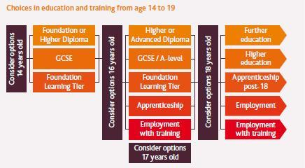

Train to Gain
Train to Gain is the national skills service meeting the needs of employers of all sizes and in all sectors to improve the skills of their employees as a route to improving their business performance. The service offers skills advice on everything from basic skills through to leadership and management training.
The service aims to encourage all employers to realise the benefits that learning and skills can bring whilst recognising that different sized businesses or businesses from different sectors face different challenges. The service therefore recognises this and is tailored to meet these needs. For example, those employers with 5,000 or more employees will receive advice from a specific service that advises national employers- the National Employer Service.
The Train to Gain service offers access to skills and training advice via three different routes:
- Business Link Advisers
- colleges
- training providers
Organising and implementing training can be challenging and time-consuming for employers. An independent Business Link Adviser, or college or training provider takes on much of the hard work - identifying quality courses, helping you schedule your training and/or business support to minimise disruption to your business.
Your Business Link Adviser will arrange to visit your office at a time that suits you. They will:
- Identify the skills that your business needs
Works with you to identify skills that will make a real difference to your business – now and into the future.
- Create a training package that is tailored to your needs
Your Business Link Adviser identifies the training and other skills that will drive your business forward, and the employees who will benefit most.
- Find local training providers
Your Business Link Adviser identifies training providers that can work with you to meet your needs. If appropriate, they’ll source local providers who can work on site - minimising disruption to your business.
- Find funding to complement your investment
Your Business Link Adviser will provide advice on financing your training. If you’re eligible for partial or full funding or subsidies, your independent Business Link Adviser will help you access the support.
- Evaluate the training
You want the best value for money from your investment. Your Business Link Adviser evaluates your training programme, making sure it has had an impact on your business success.

Five Regional NHWN Sustainability Events
Tribal have attended all 5 regional NHWN sustainability in order to present to delegates the feasibility study, set out the aims of the study and elicit feedback from the members as to what they want from a training programme, who it would be aimed at, what it should cover and how it would be used to ensure the sustainability of the NHWN.

The following pictures present the feedback taken during the five events:

Key Findings
The following is a summary of the key responses provided to Tribal during the 5 regional NHWN sustainability event question and answer sessions:
- There is a feeling amongst members that an accredited qualification (whilst sounding attractive) would not suit NHWN members, owing to: Time; Cost; Variation is skills and needs; and Volunteer base; but is a good idea for new people coming in and young people
- There is a feeling that NVQs are not appropriate to the NHWN as there is no occupational competency to assess
- People are wary of the constraints placed on themselves doing an accredited training course
- People are happy with the existing toolkit, but feel that it does not go into enough detail and they do not know who to turn to when they have problems
- There is a feeling that having access to a coach or a mentor to support a newly developed toolkit would be very useful and may support the sustainability of learning
- People seemed very interested in piloting the idea of developing the toolkit and having access to coaches/mentors to support their skills development
- There was a feeling that accredited training could be used as a way of attracting young people – but a growing concern that there didn’t seem to have an end goal (i.e. should the training on offer to young people improve their employability and career prospects and if so how would this support the sustainability of the NHWN)
- Cost and paying for training was not accepted very well by the members and would be a considerable obstacle to any type of training programme
- The areas of development covered (see photos of feedback):
  - Fundraising
  - Communication
  - Influencing
  - Negotiation
  - Events management
  - Leadership
  - Youth engagement
- People positively reacted to the idea of a VRQ (aimed mainly at young people coming into the movement) and recognised the potential for the qualification to attract funding and build in some element of sustainability.

Generally, people were very receptive to the idea that training should be enhanced and used to share good practice and potentially bring in more young people into the NHWN.

Recommendation(s)
Having reviewed the feasibility study and taken time to study the response to the question and answer sessions during the 5 regional NHWN sustainability events, it is our recommendation that initially the Neighbourhood and Home Watch Network invest in re-developing and designing the existing toolkit (already being worked on through ERS, the Design Council and Live|Work) and support its roll out by developing regional coaches and mentors who can engage with (and support) individual members interacting with the new toolkit.

The new toolkit should:
- Be a more comprehensive distance learning pack that is both available in electronic and paper-based formats
- Cover the top training needs identified by NHWN members
- Be mapped to National Occupational Standards (NOS) – providing a future option on turning the non-accredited learning into accredited
- Reflect the diverse groups of NHWN members and incorporate case studies and good practice

In supporting the new toolkit, there should be:
- A number regional coaches and mentors tasked with engaging individuals interacting with the new toolkit and providing coaching and mentoring support – these chosen individuals should ideally sit at Local Associations District/Borough Level and be provided with accredited coaching and mentoring training.
- A commitment by the regional coaches to regularly engage with members in order to identify and train new coaches and mentors.

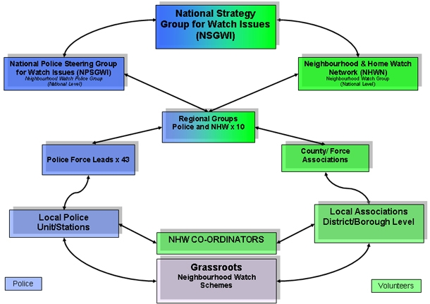

Next Steps
- As some of the re-development and re-design of the toolkits is currently underway, and taking into the interest in developing a VRQ, we would recommend that the following six steps are taken
  - Further develop a finalise the 5 modules
  - Use the 5 modules to identify how they can be adapted and made into a VRQ
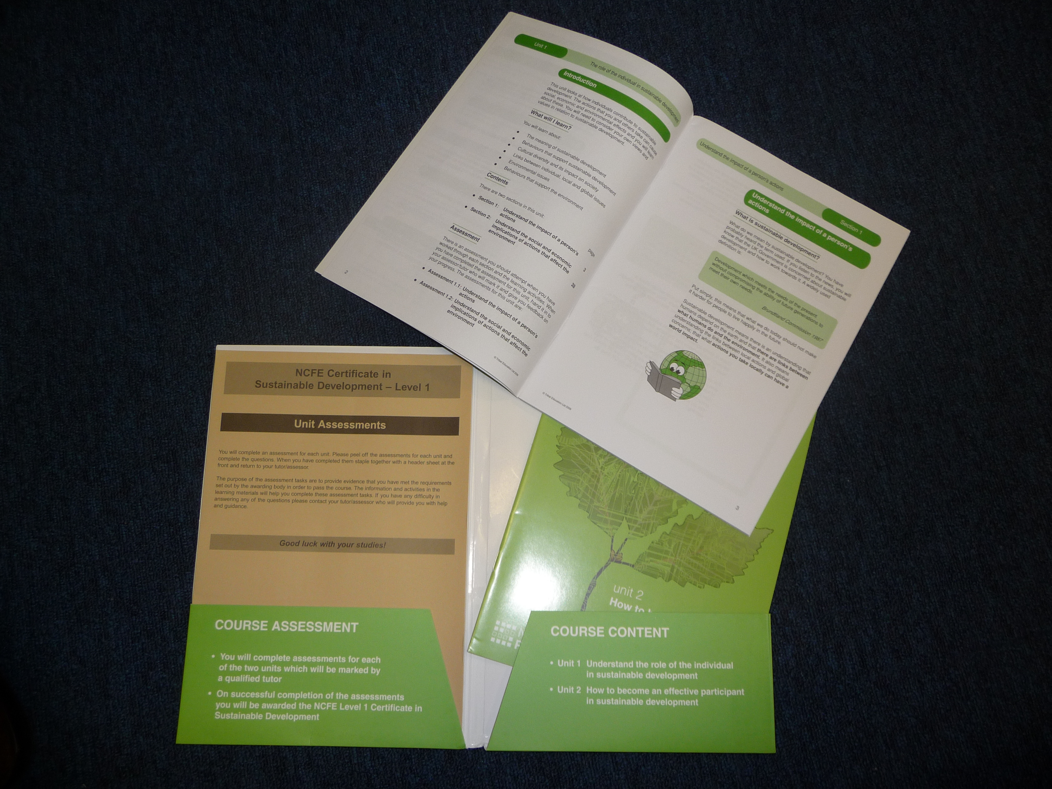
Certificate in Sustainable Development Level 1 (VRQ Pack)

- Commission an organisation to write the units for a VRQ based on the 5 modules
- Look at piloting the new VRQ (maybe in partnership with Catch22). Potentially drawing down funding from a local authority, DWP or the Home Office to run a small project using the training as a route to employment/positive activity for young people
- Seek additional funding for the roll-out of the VRQ
- Roll-out the VRQ

Additionally, the NHWN should initially identify individuals to become regional coaches and mentors and invest in their training and development – supporting the sustainability of the new five modules.

Appendix L:
Feasibility Study for a Single Communications System (Tribal)

This is a restricted circulation document, for reasons of commercial confidentiality.

